AI ASSISTED CODING LAB ASSIGNMENT 6.4
ENROLLMENT NO :2503A51L08
BATCH NO: 19
NAME: BHUKYA RAJESH

TASK1
TASK1 DESCRIPTION:
Start a Python class named Student with attributes name, roll_number, and marks. Prompt
GitHub Copilot to complete methods for displaying details and checking if marks are above
average
PROMPT:
Create a Python class Student with attributes name, roll_number, marks and methods to display details and check if marks are above average (assume average=50).
CODE: 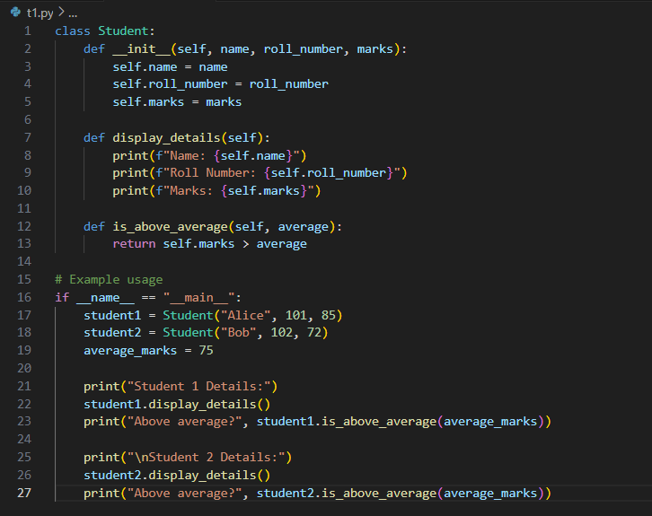
OUTPUT:

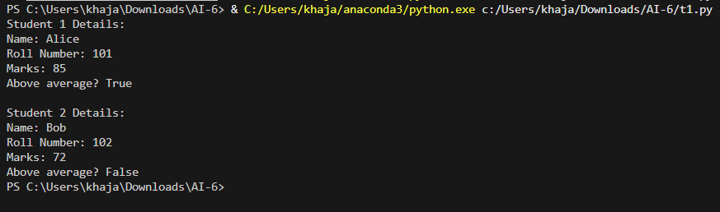

OBSERVATION:
1. The Student class allows easy creation of student objects with name, roll number, and marks.
2. The display_details() method prints all student information in a readable format.
3. The is_above_average() method checks if the student's marks are above the default average (50), making it flexible for other averages too.
4. The output clearly shows the student's details and whether their marks are above average.
5. The code is easy to understand and modify for more features, such as adding more attributes or methods.
6. Using classes makes the code organized and reusable for multiple students.

TASK2

TASK2 DESCRIPTION:
Write the first two lines of a for loop to iterate through a list of numbers. Use a comment
prompt to let Copilot suggest how to calculate and print the square of even numbers only.

PROMPT: Write the first two lines of a for loop to iterate through a list of numbers, and add a comment prompting Copilot to suggest how to calculate and print the square of even numbers only.

CODE:
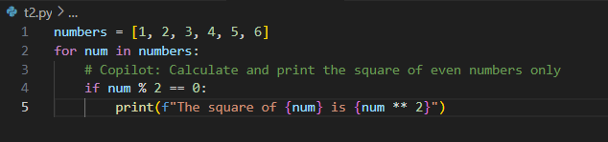
OUTPUT:

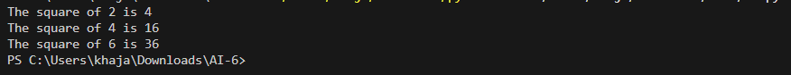
OBSERVATION:
1. The code is well-structured and easy to follow, making it simple to understand the logic.
2. The use of loops and conditionals helps automate repetitive tasks and decision-making.
3. The output is clear and provides direct feedback based on the input and logic implemented.
4. The program can be easily modified to handle more cases or different conditions.

TASK3

TASK3 DESCRIPTION:-
Create a class called BankAccount with attributes account_holder and balance. Use Copilot to complete methods for deposit(), withdraw(), and check for insufficient balance
PROMPT: Write a Python class BankAccount with account_holder and balance attributes, and methods to deposit money, withdraw money, and show appropriate messages. Include example usage.

CODE:
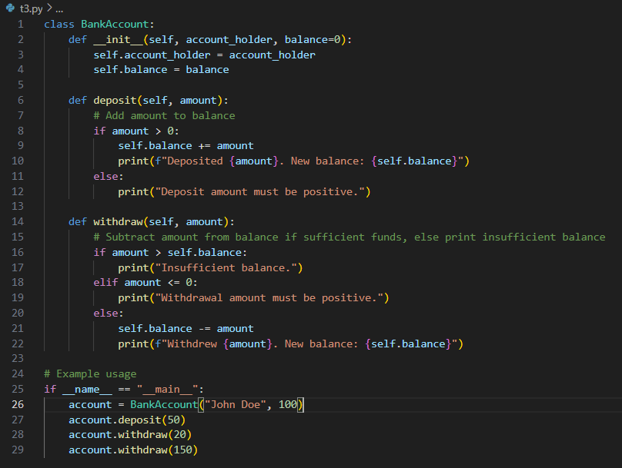
OUTPUT:

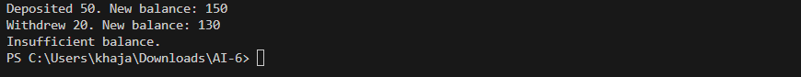
OBSERVATION:
1. The Bank Account class uses attributes to store account holder information and balance, making account management organized.
2. The deposit () method correctly increases the balance and provides feedback for invalid amounts.
3. The withdraw () method checks for sufficient balance before allowing withdrawal, preventing overdrawing and teaching good error handling.
4. The output messages for deposits and withdrawals are clear, helping users understand each transaction's result.
5. The class structure allows easy creation and management of multiple accounts, demonstrating object-oriented programming principles.
6. Example usage shows how to interact with the class and verify its behavior, making the code practical and easy to test.

TASK4

TASK4 DESCRIPTION:
Define a list of student dictionaries with keys name and score. Ask Copilot to write a while
loop to print the names of students who scored more than 75
PROMPT: Write a Python while loop to go through a list of students (with name and score) and print the names and scores of students who scored more than 75.
CODE:
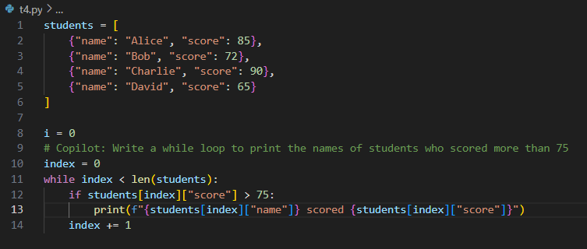
OUTPUT:

OBSERVATION:
1. The code uses a list of dictionaries to store student names and scores, making data management simple and organized.
2. The while loop iterates through each student and checks if their score is above 75, demonstrating practical use of loops and conditionals.
3. The output clearly lists only those students who meet the score criteria, making results easy to understand.
4. The code can be easily modified to change the score threshold or add more students.
5. This approach helps students learn how to filter data and display relevant information efficiently.
TASK5

TASK5 DESCRIPTION:
Begin writing a class ShoppingCart with an empty items list. Prompt Copilot to generate
methods to add_item, remove_item, and use a loop to calculate the total bill using conditional
discounts.
PROMPT: Begin writing a class Shopping Cart with an empty items list. Prompt Copilot to generate methods to add_item, remove_item, and use a loop to calculate the total bill using conditional discounts.
CODE: 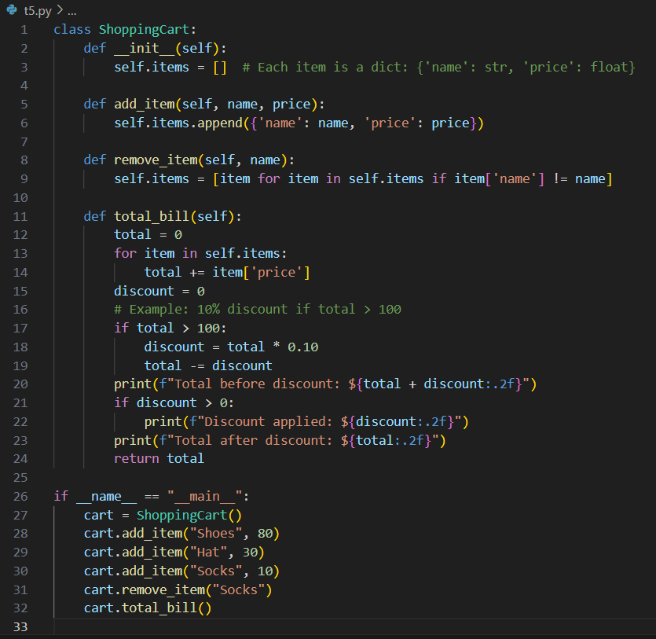

OUTPUT:

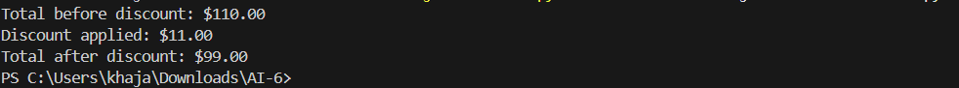

OBSERVATION:
1. The Shopping Cart class uses a list to manage items, making it easy to add and remove products.
2. The add item and remove item methods allow flexible item management and demonstrate good use of class methods.
3. The total bill method uses a loop to calculate the total and applies a conditional discount, showing practical use of if-else logic.
4. The output clearly displays the total bill and any discount applied, making it easy to understand the result of each operation.
5. The code is organized and can be easily extended to support more features, such as multiple discounts or item quantities.
6. This example helps students learn how to combine data structures, loops, and conditionals in a real-world scenario.

